**AIRLINES MANAGEMENT SYSTEM**

**(DEVOLOPER)**

**Mentor : SRI L .LAKSHMI NARAYANA**

**Team ID :** LTVIP2024TMID11758

**Team Leader : KAPAKAYALA SURESH**

**Hall Ticket Number :** 213887102035

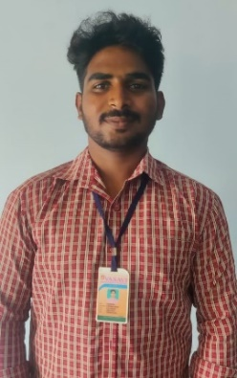 **Mail Id :** sureshdsp279@gmail.com

**Team Member : GUBBALA PAVAN VENKATESH SAI RAM**

**Hall Ticket Number :** 213887102030

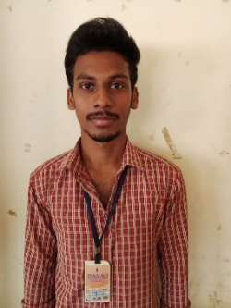 **Mail Id :** pavansaisp21@gmail.com

**Team Member : GOLTHI SAI VARUN**

**Hall Ticket Number :** 213887102026

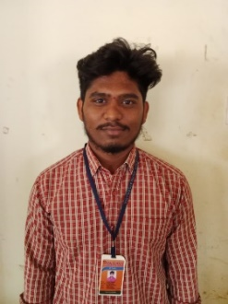 **Mail id :** saivarungolthi@gmail.com

**Team Member : PALURI UMA MANI SHANKAR**

**Hall Ticket Number :** 213887102056

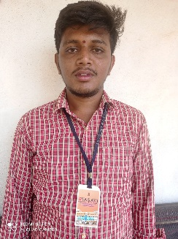 **Mail Id** : naiduc505@gmail.com

**Team Member : TIPPANI MANIKANTA**

**Hall Ticket Number :** 213887102071

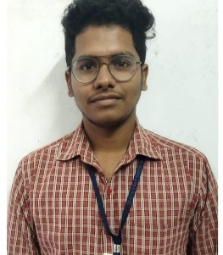 **Mail Id :** tippanimanikanta26@gmail.com

### Airlines Management System

This project aims to enhance the efficiency and effectiveness of managing flights, reservations, and passenger information. The system enables airlines to manage their fleet, schedule flights, allocate seats, and handle bookings seamlessly. It provides functionalities for ticket reservations, seat availability checks, passenger check-ins, and baggage handling. Additionally, the system facilitates communication between airlines, airports, and passengers through automated notifications and alerts. With its user-friendly interface and robust database management, the Airlines Management System optimizes workflow, improves customer satisfaction, and ensures smooth operations for the entire airline industry.

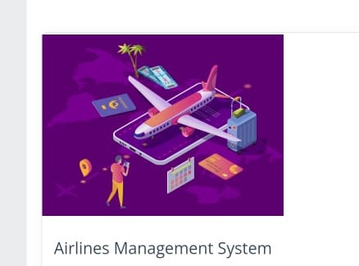

**Salesforce Account details:**

**User Name :** [suresh@vasavi.com](mailto:suresh@vasavi.com)

**Password :** Amma143225

**What is Salesforce developer ?**

Salesforce is your customer success platform, designed to help you sell, service, market, analyze, and connect with your customers.

Salesforce has everything you need to run your business from anywhere.

Using standard products and features,

you can manage relationships with prospects and customers,

collaborate and engage with employees and partners,

and store your data securely in the cloud.



**INTERNSHIP PROJECT GIVEN BY**

**SMARTINTERNZ**

### Creating Developer Account

**TSK-180429**

**1)Salesforce Devoloper**

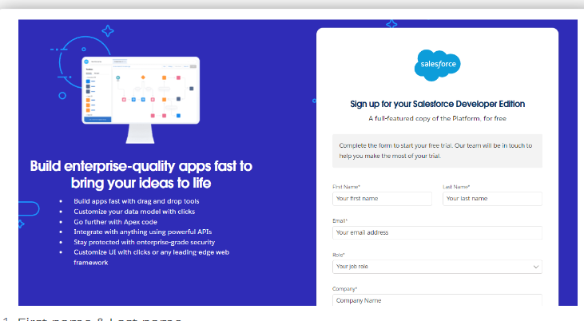

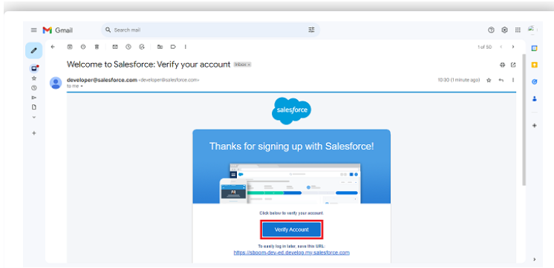

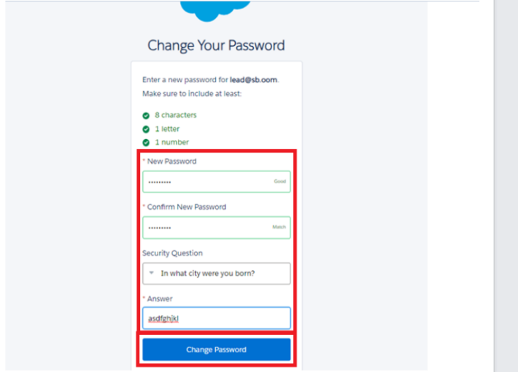

**Account Activation**

**TSK-180430**

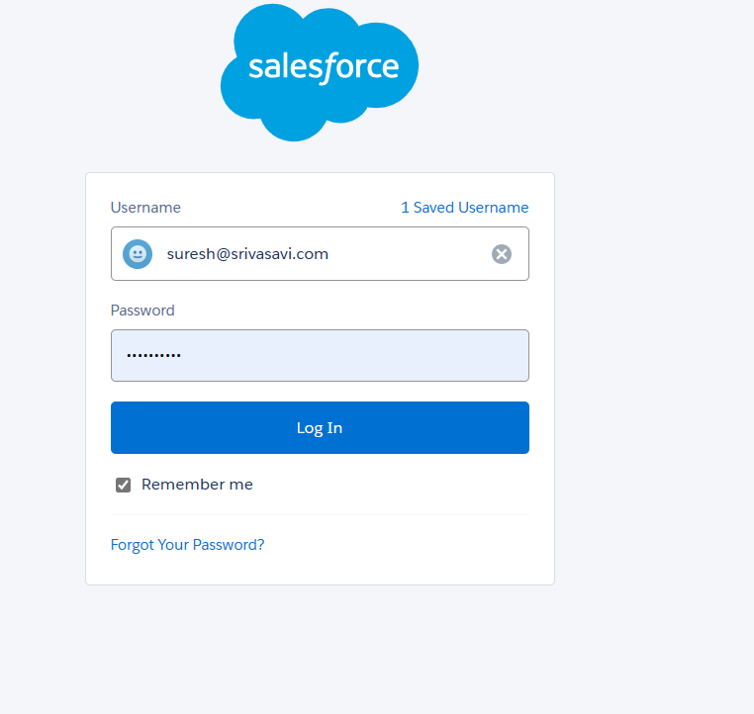

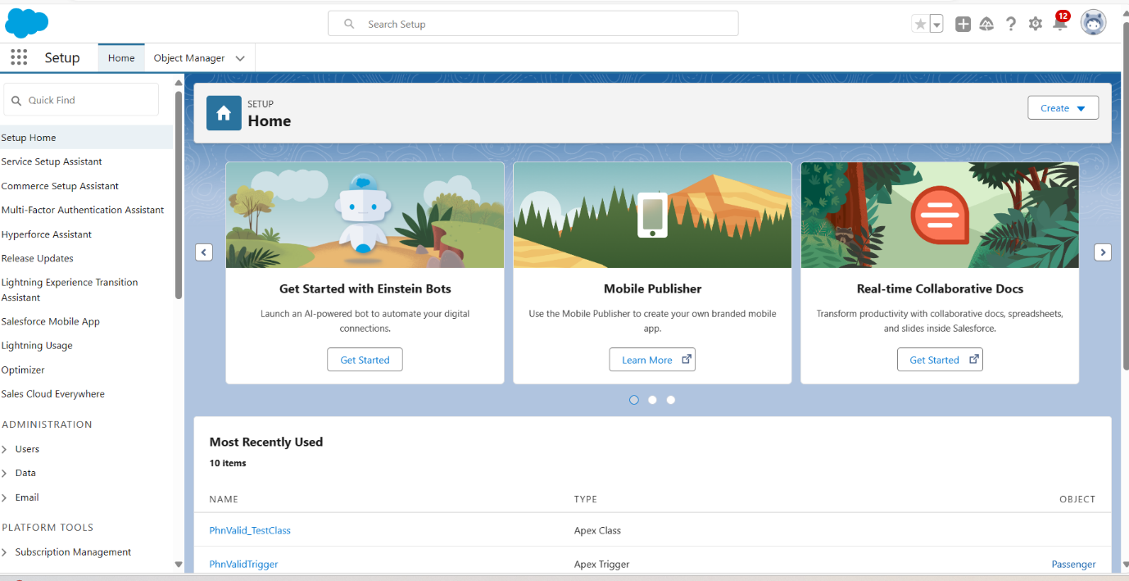

**2) Object Creating on Flight**

**TSK-180431**

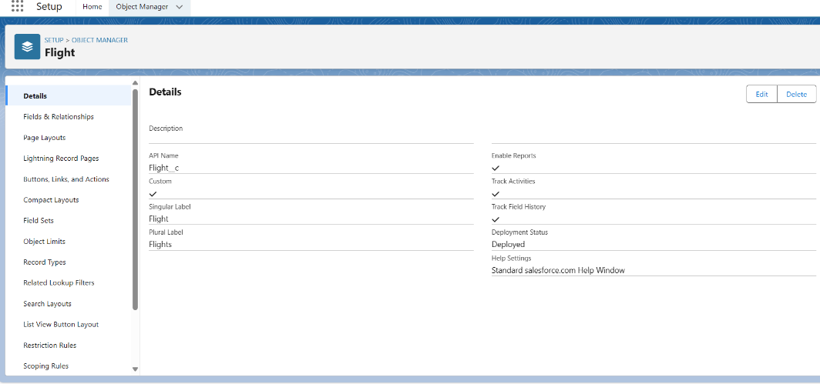

**Object Created on Booking**

**TSK-180432**

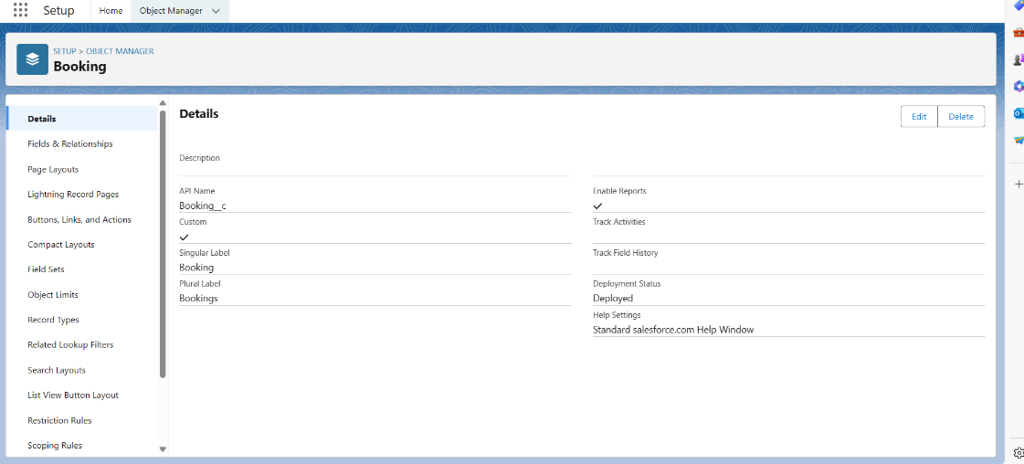

**Object created on passenger and crew**

**TSK-180433**

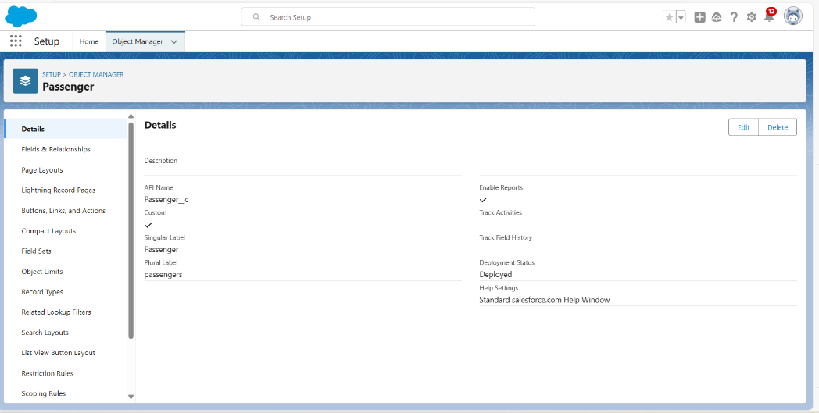

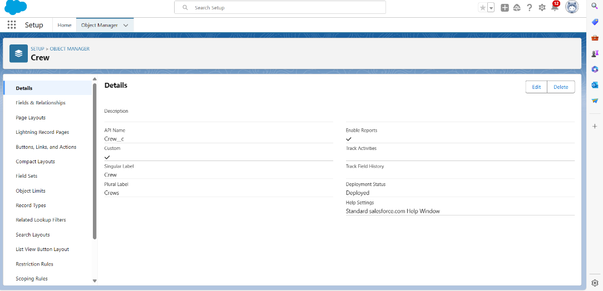

**3) Tabs created on flights**

**TSK-180434**

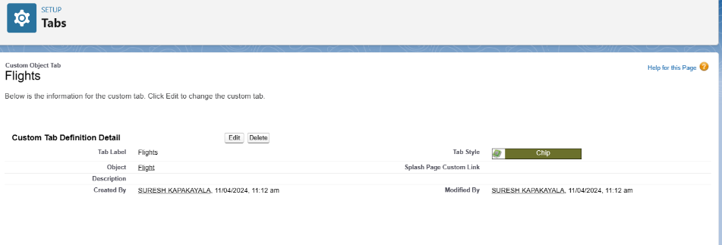

**Tabs created on bookings**

**TSK-180435**

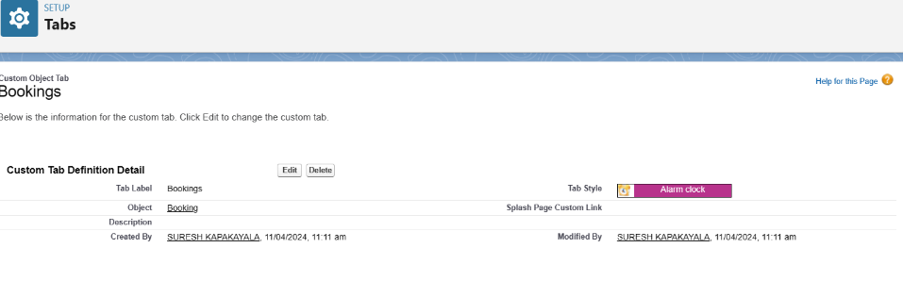

**Tabs created on Crews and passengers**

**TSK-180436**

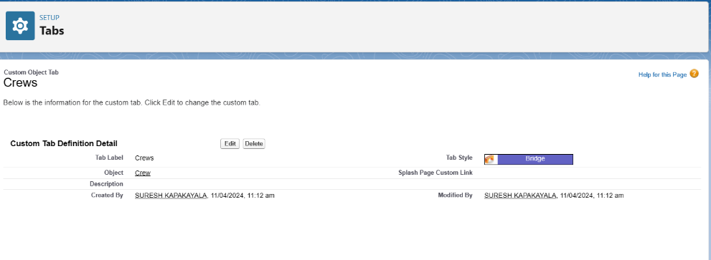

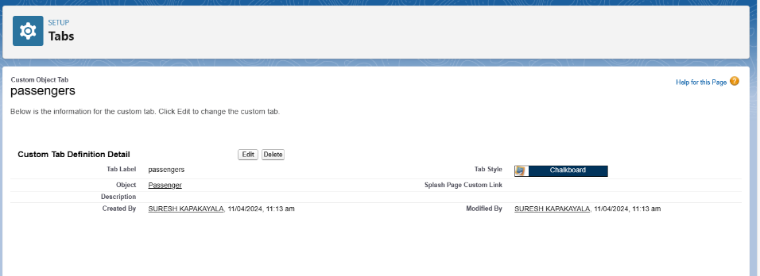

**4) The Lightning App**

**TSK-180437**

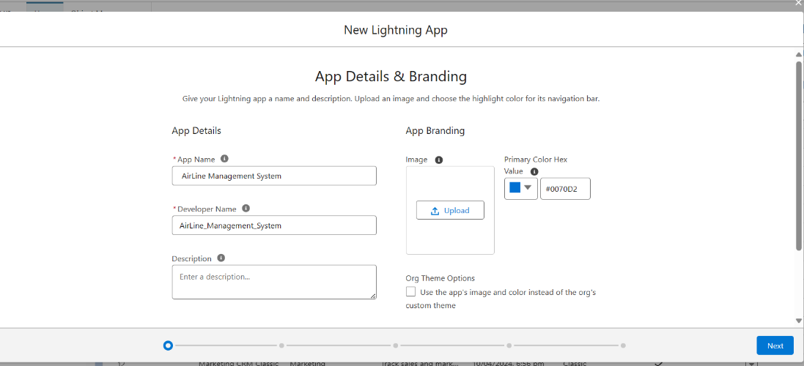

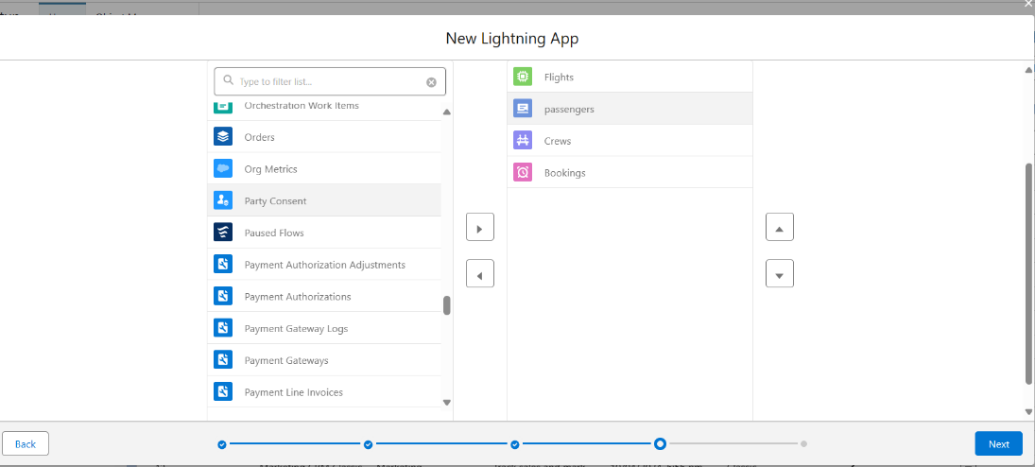

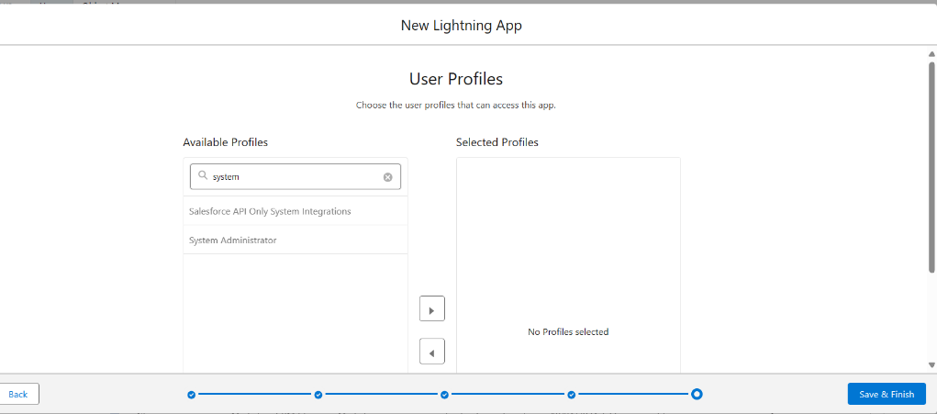

**Created the lightning app**

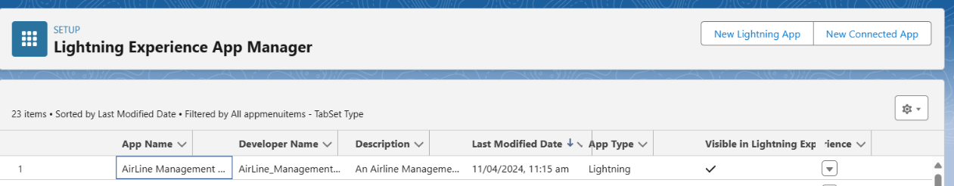

**5) Creating the Fields**

**TSK-180438**

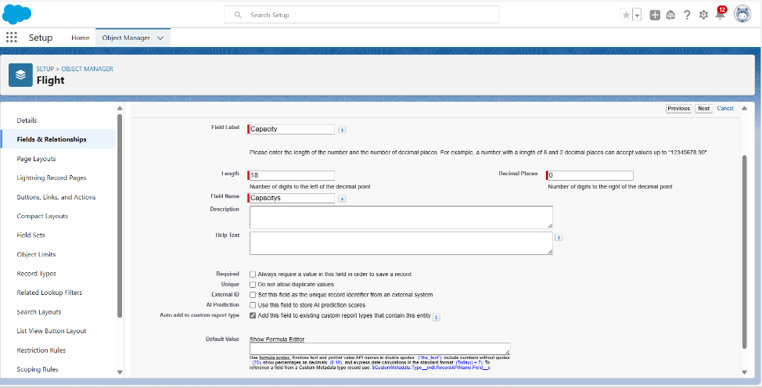

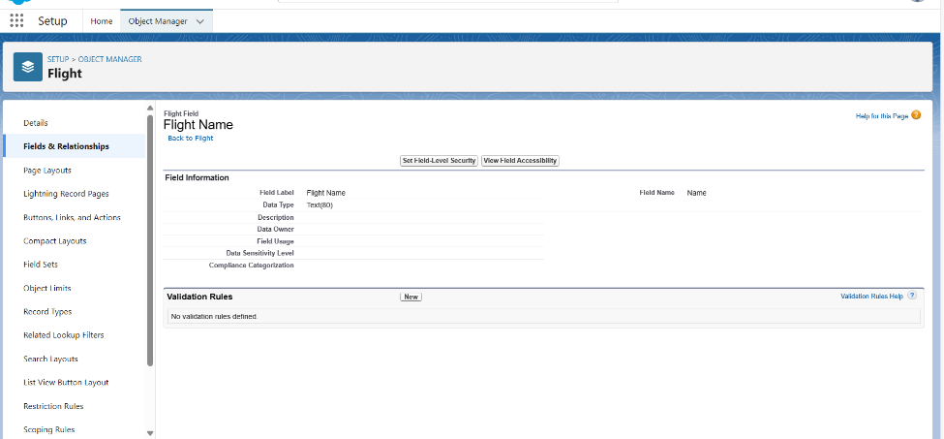

**Created depature date on booking**

**TSK-180439**

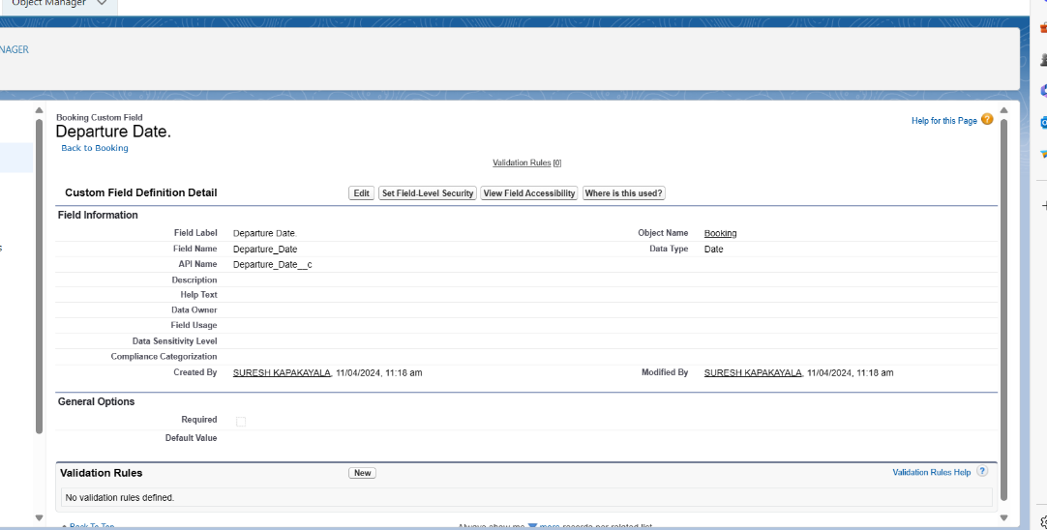

**Created picklist field in flight**

**TSK-180440**

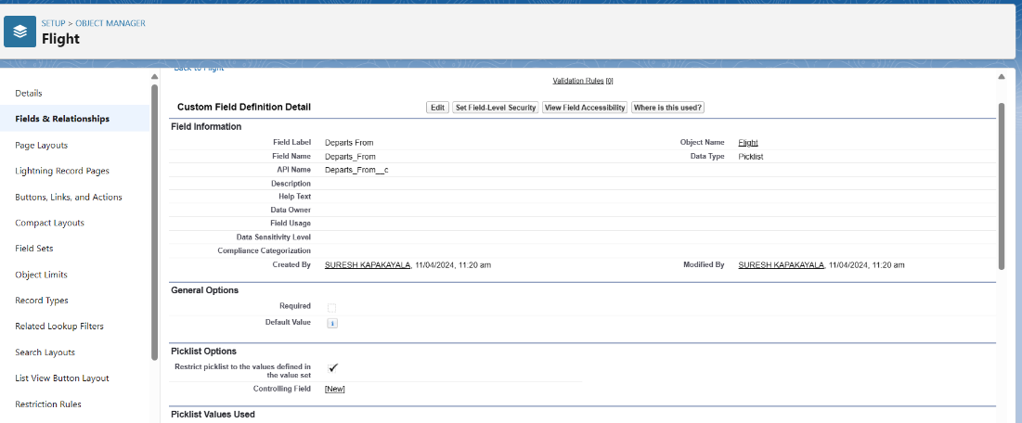

### **Creating Lookup Relationship Between Flight And Booking**

**TSK-180441**

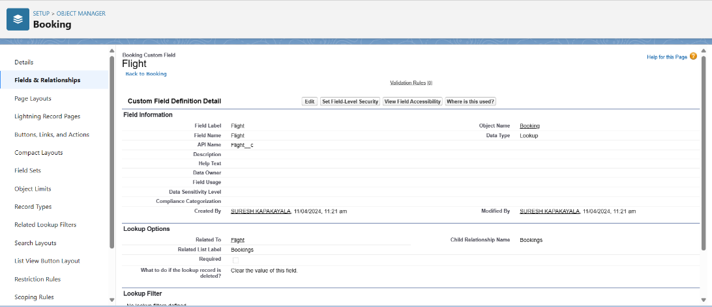

### **Created Remaining Fields**

**TSK_180442**

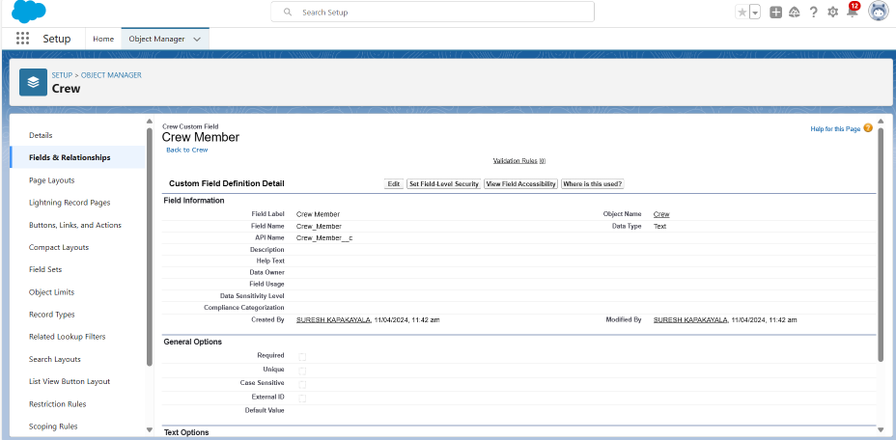

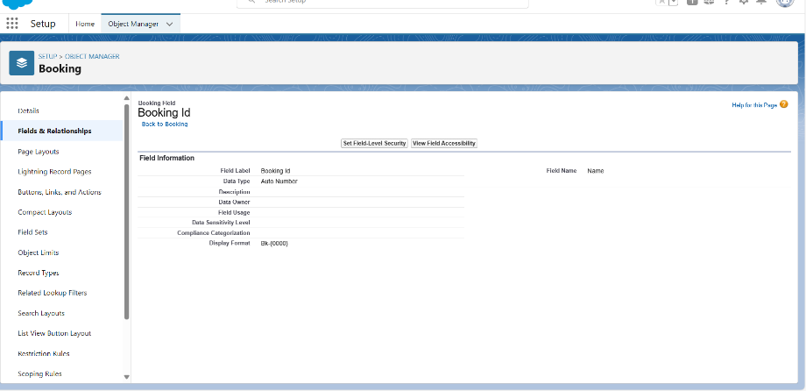

### **Created Field Dependencies**

**TSK_180443**

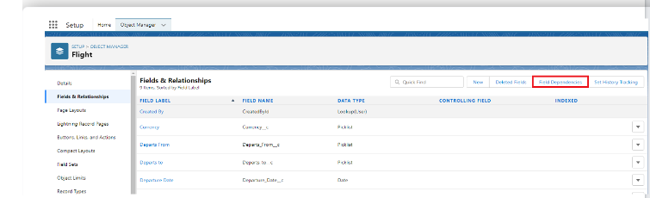

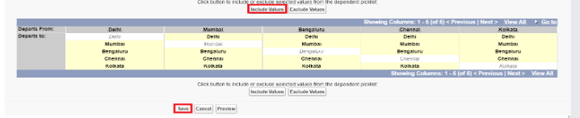

### **Field Dependencies on booking objects**

**TSK-180444**

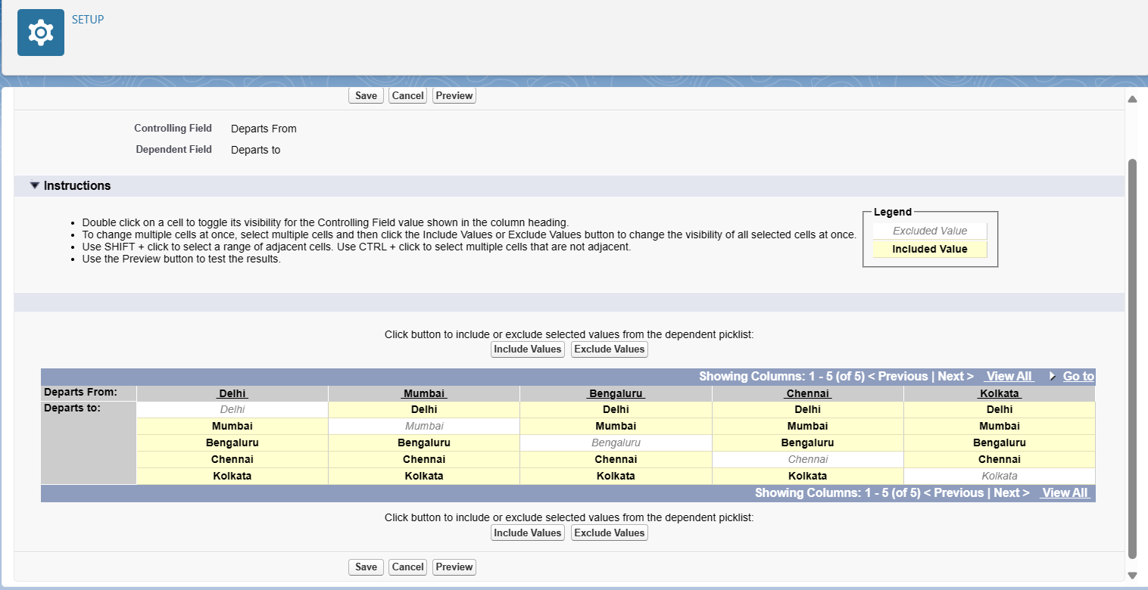

**Schema builder**

**TSK-180445**

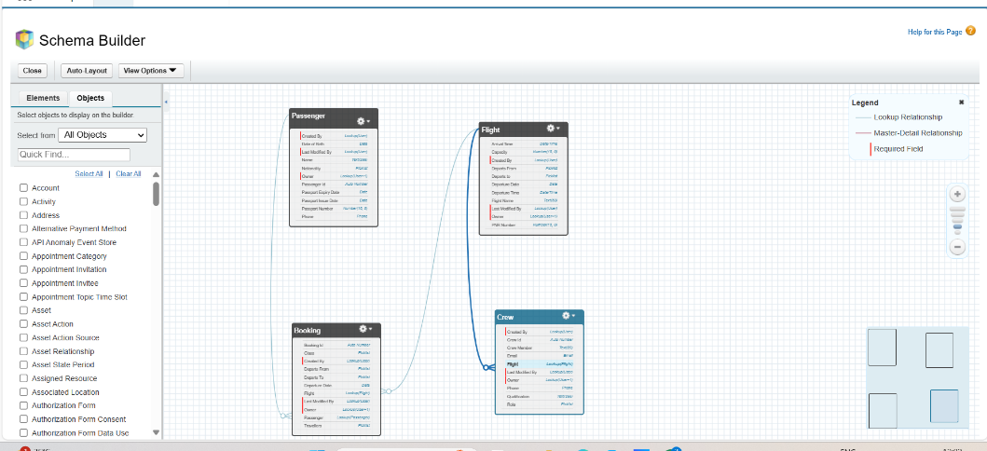

### **6) Create a passenger Record**

### **TSK-180447**

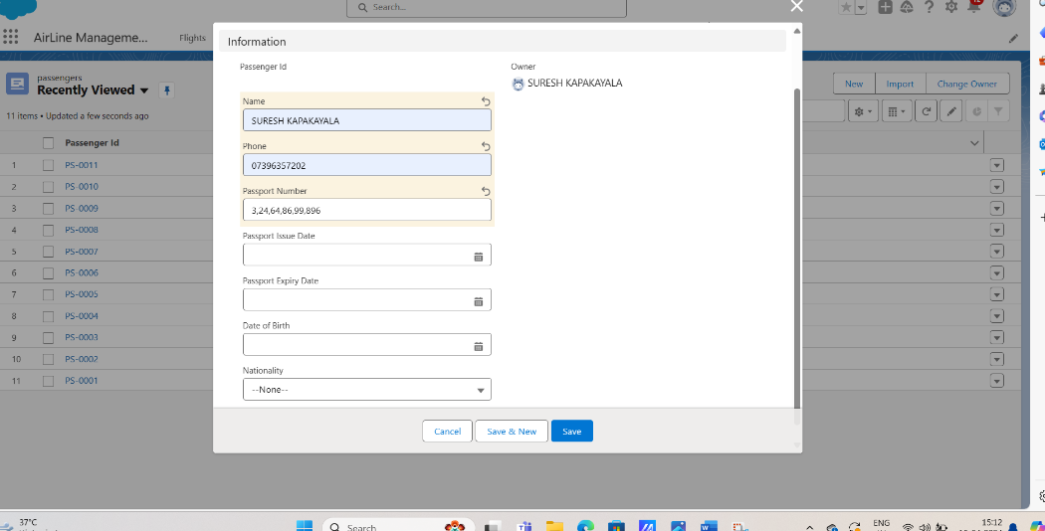

**Viewed a passenger Record**

**TSK-180447**

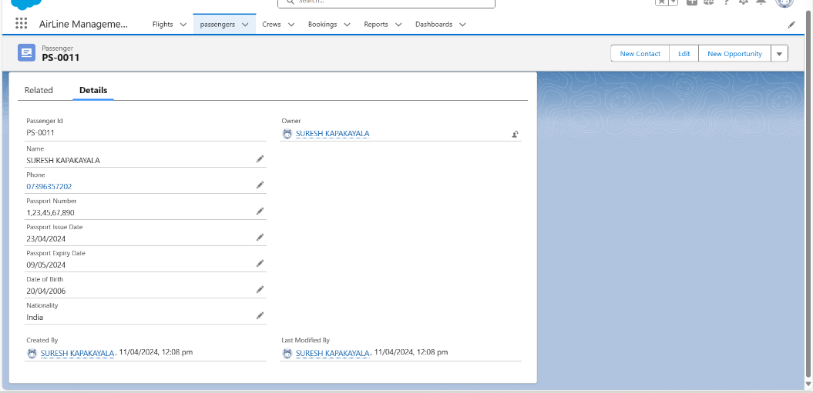

**Deleted a passenger Record**

**TSK-180448**

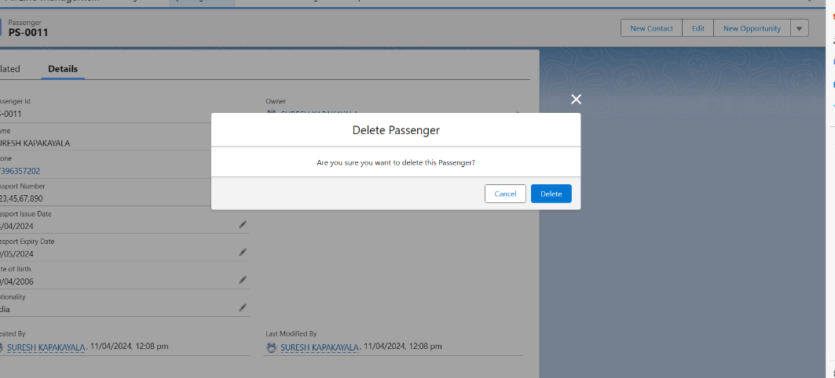

**Created 10 records on passenger**

**TSK-180449**

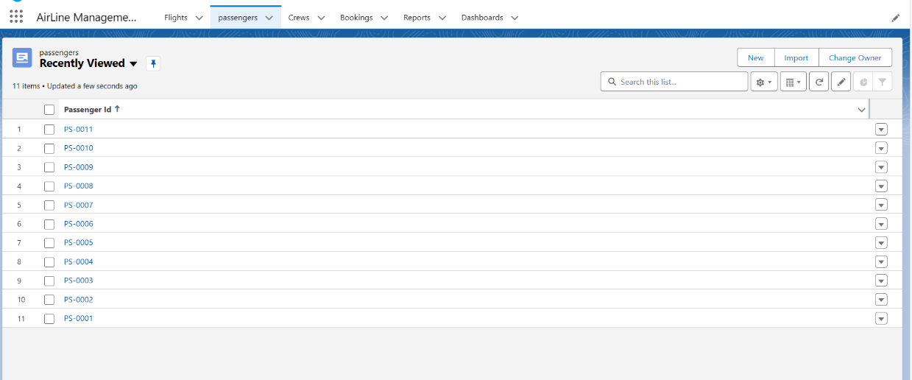

**Created 10 records on Flight**

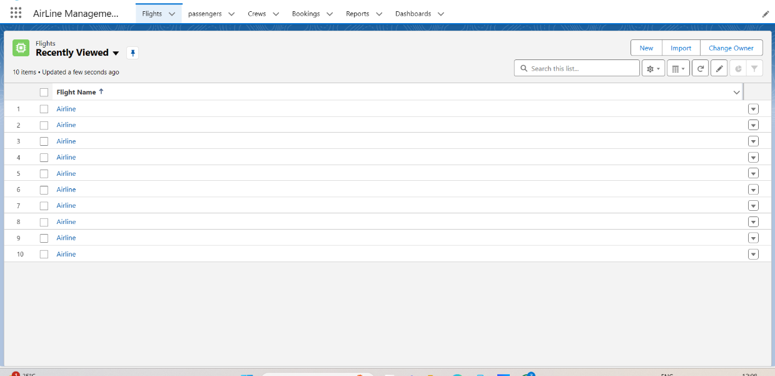

**Created 10 records on Crew**

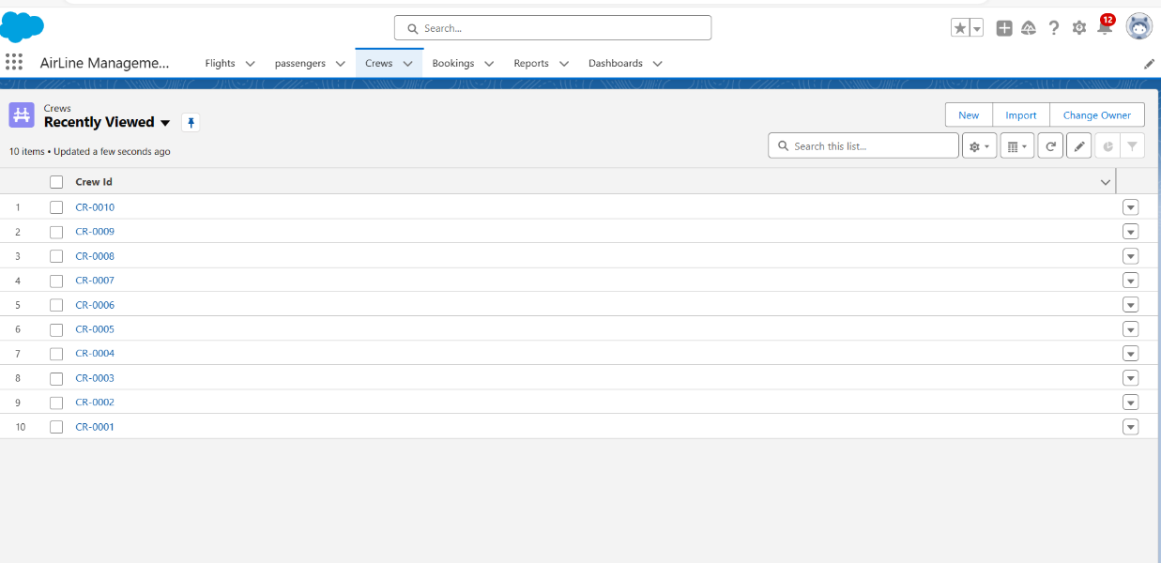

**Created 10 records on Booking**

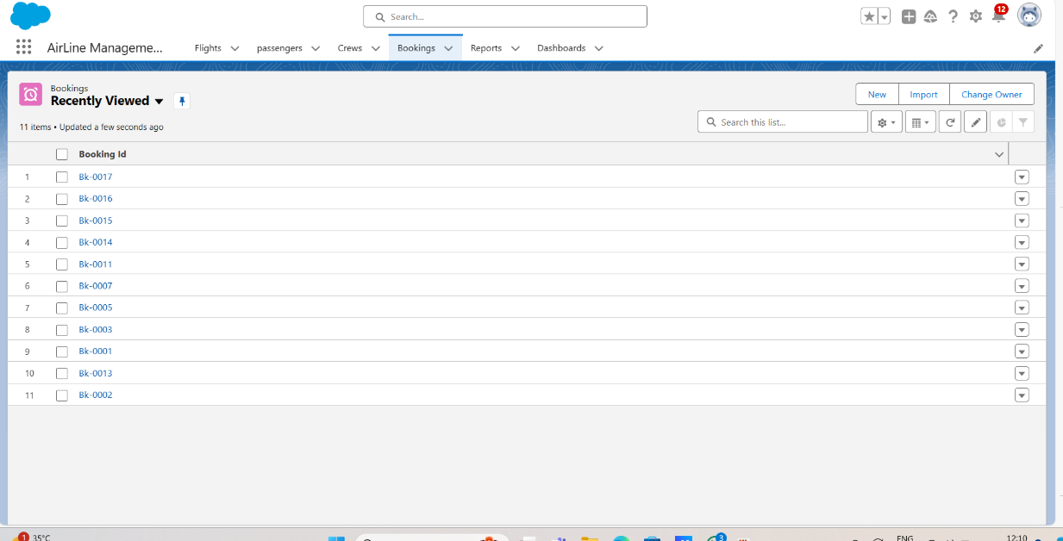

### **7) Creating General Admin Profile**

**TSK-180450**

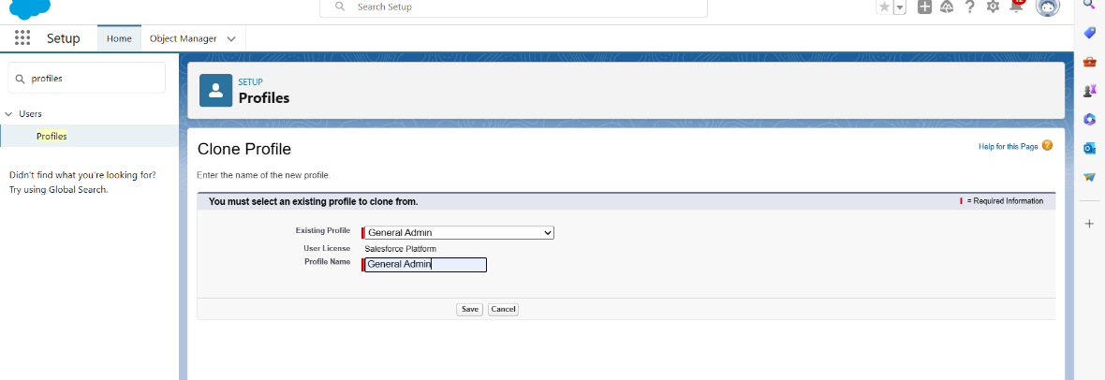

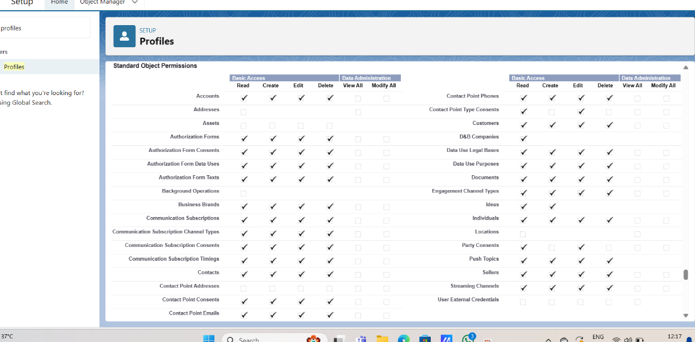

**Created general admin profile**

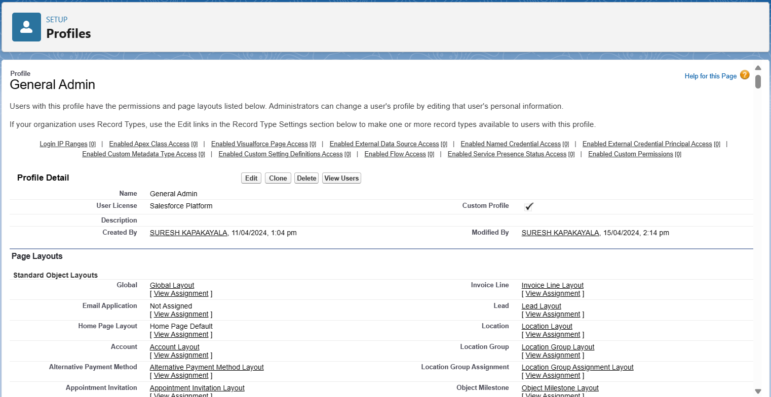

**Created management admin profile**

**TSK-180451**

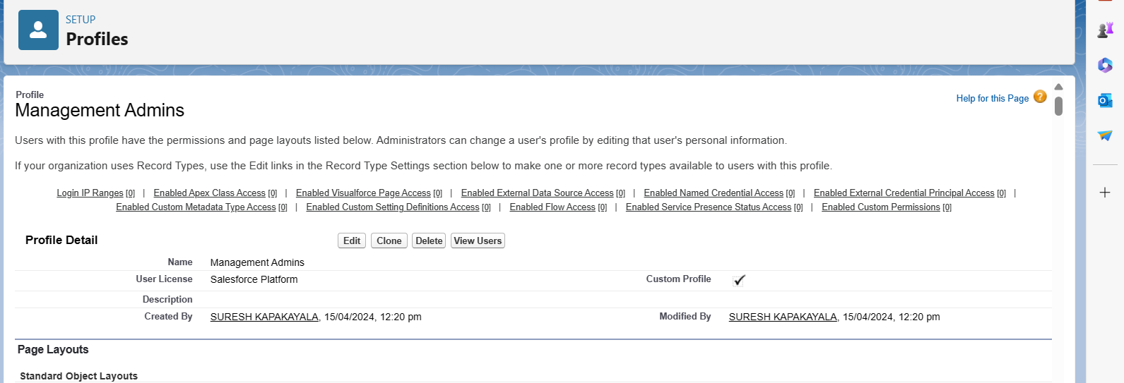

**Created senior admin profile**

**TSK-180452**

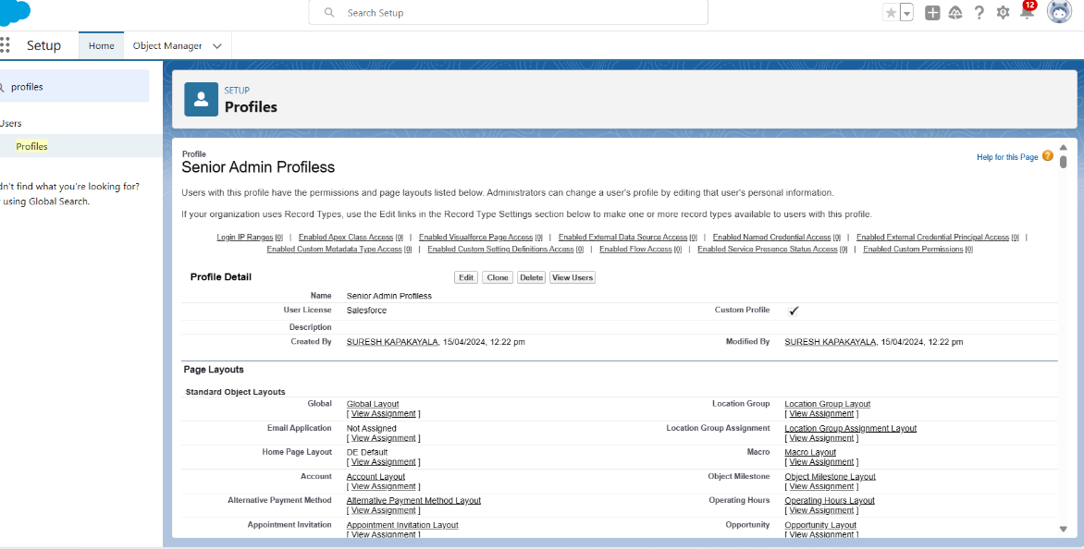

### **8) Creating Admin Manager Role**

**TSK-180453**

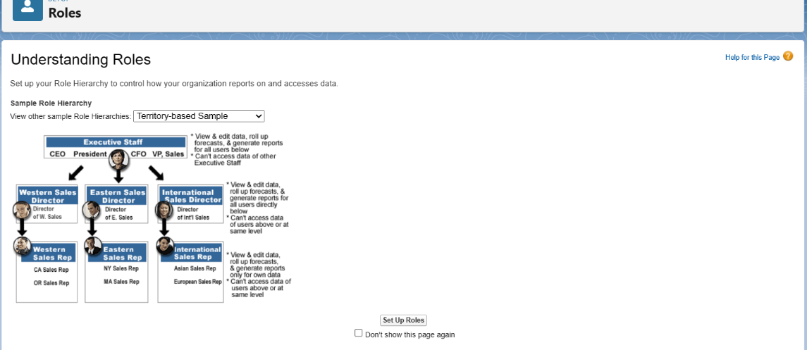

### **Created Admin Manager Role**

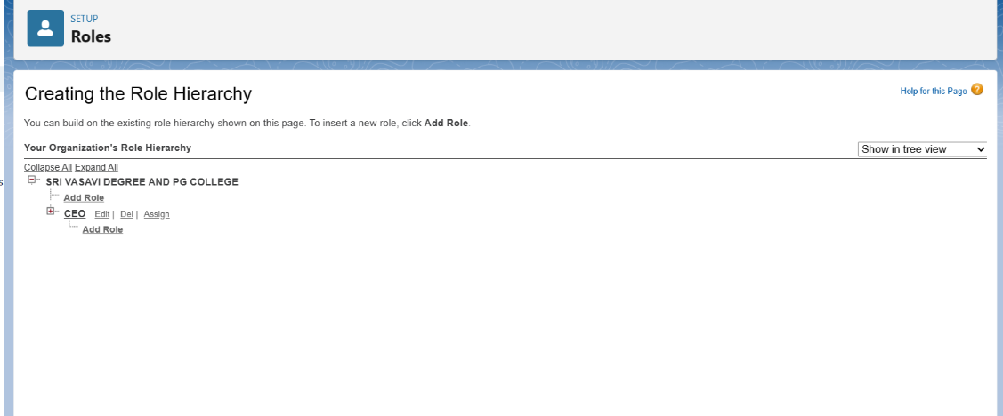

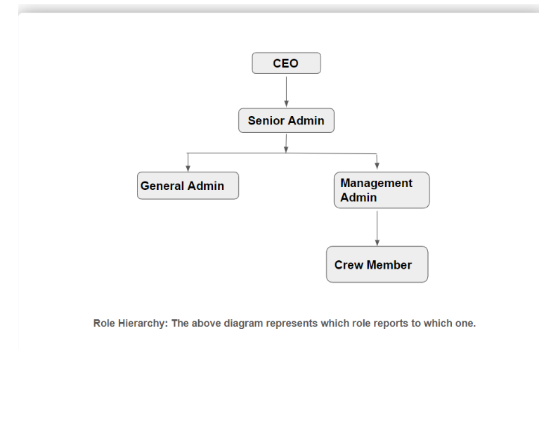

**Created General admin role**

**TSK-180454**

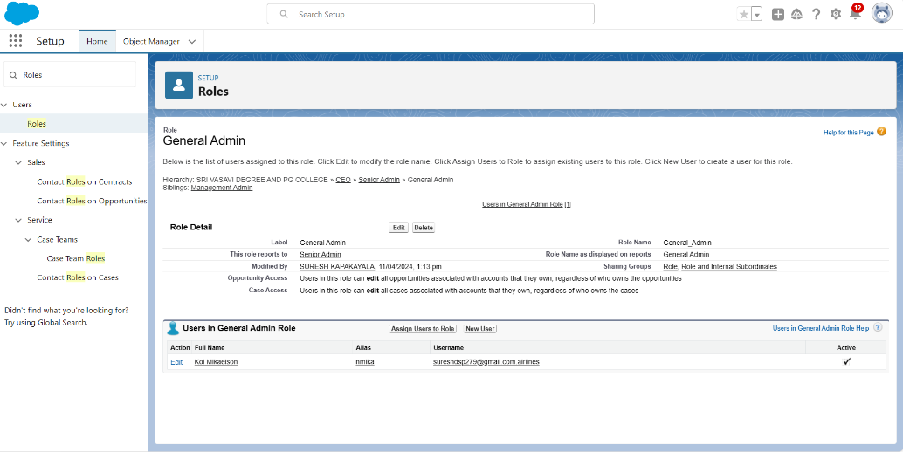

**Created General management admin role**

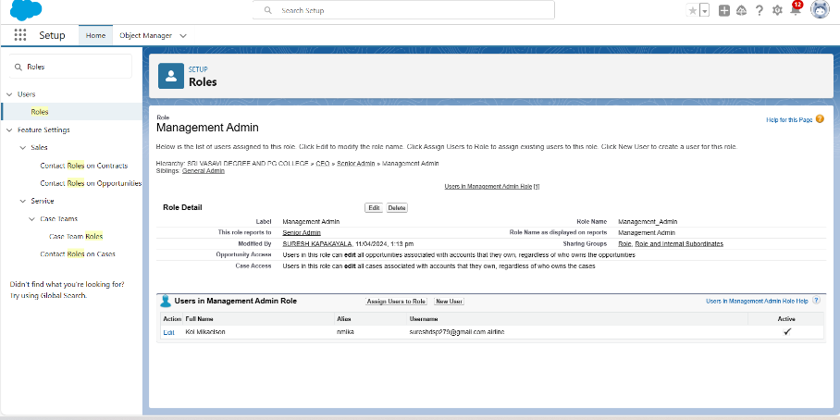

**Created crew member role**

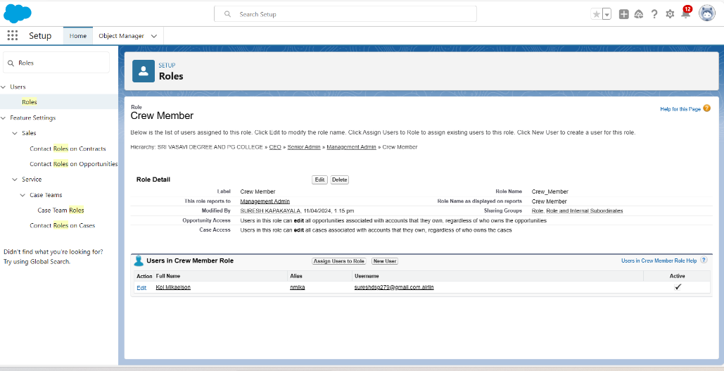

**9) Created user**

**TSK-180455**

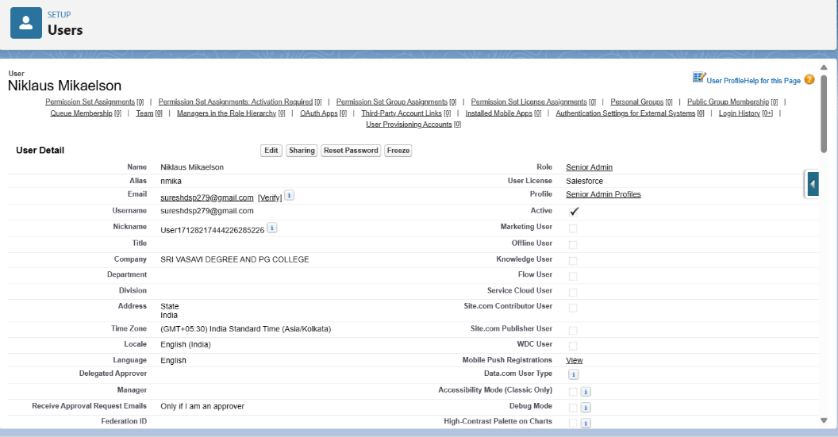

**Created second user**

**TSK-180456**

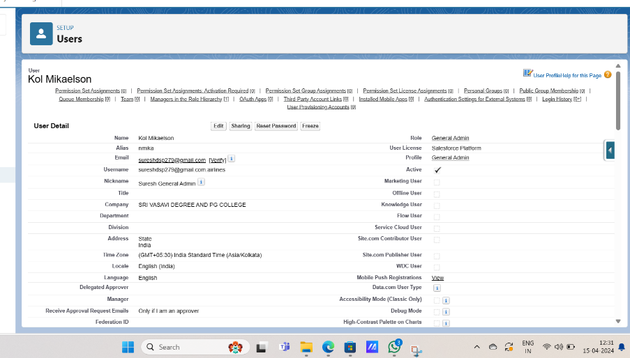

**Created user on management admin and crew member**

**TSK-180457**

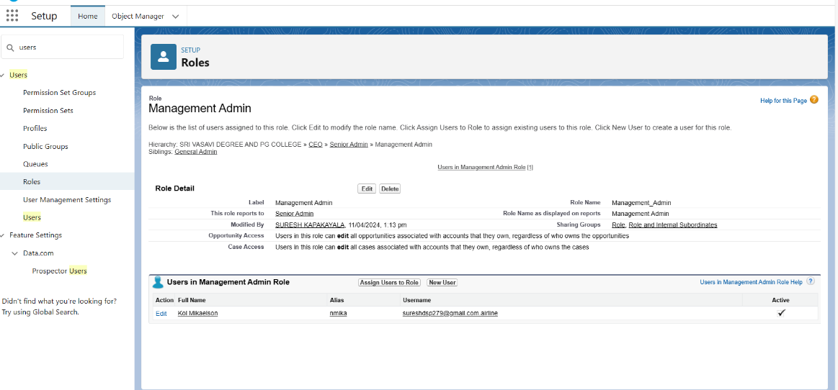

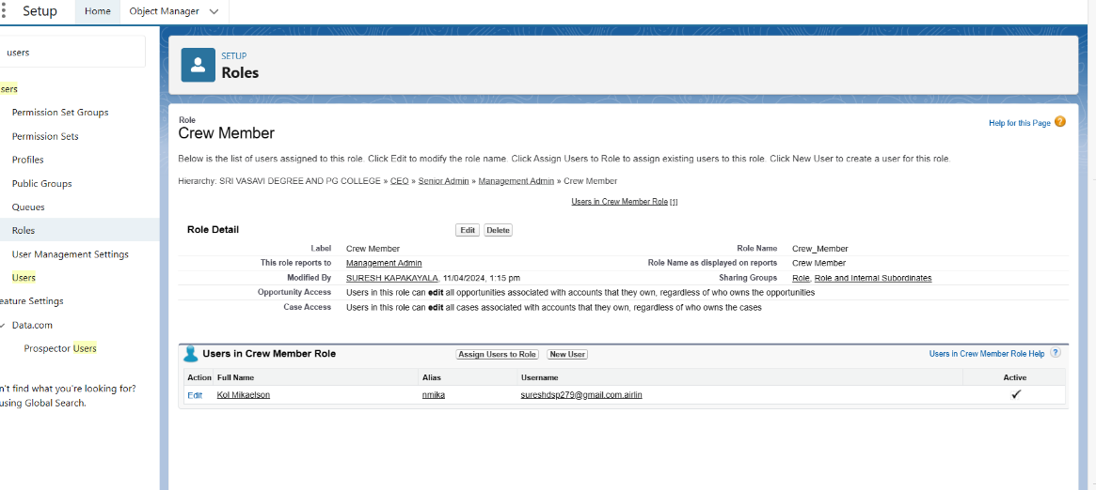

**10) Creating Reports**

**TSK-180458**

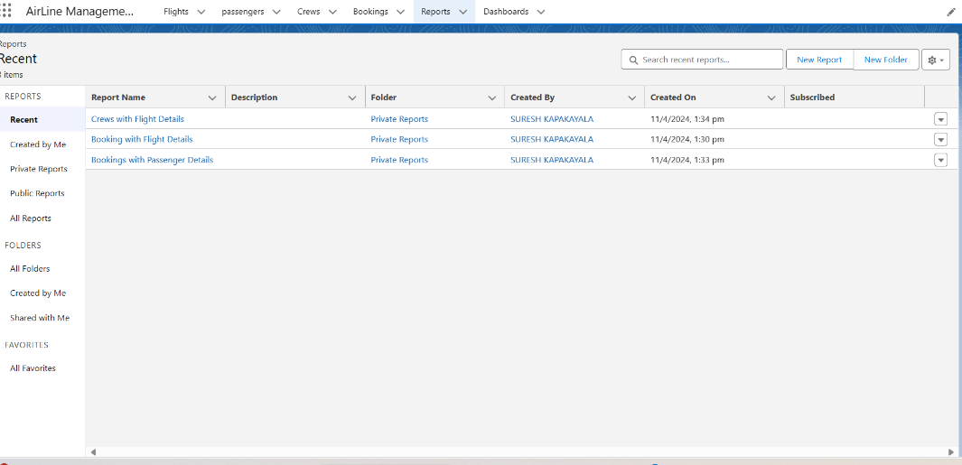

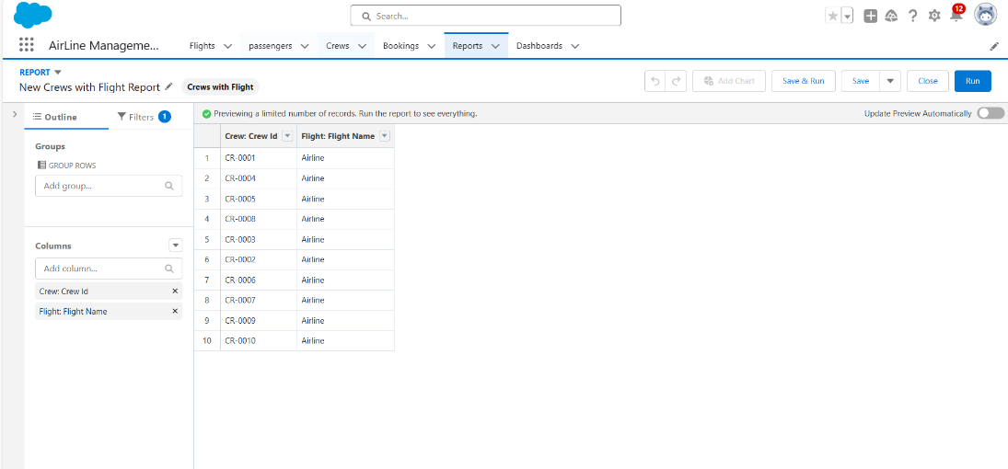

**Created reports**

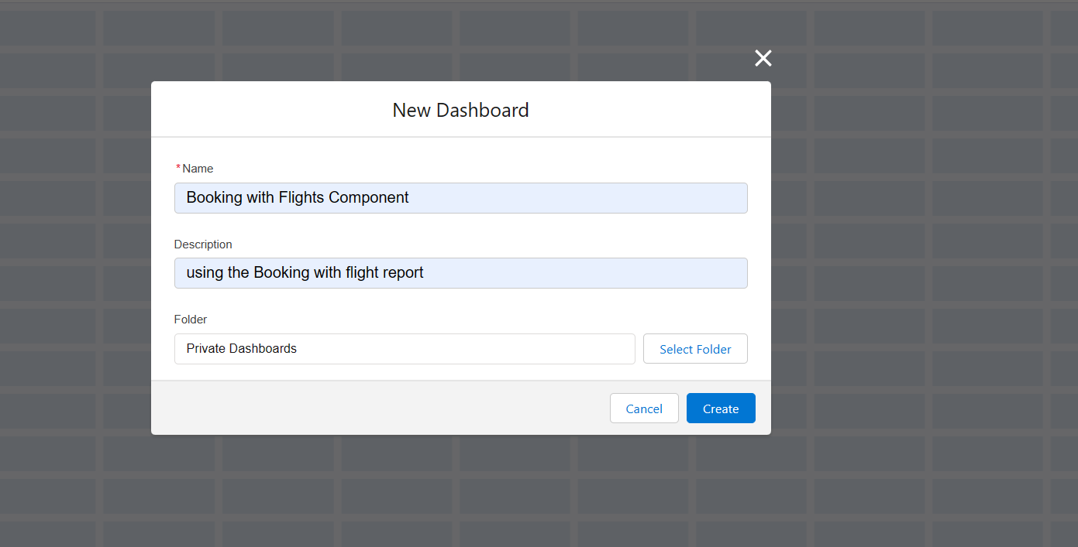

**TSK-180459**

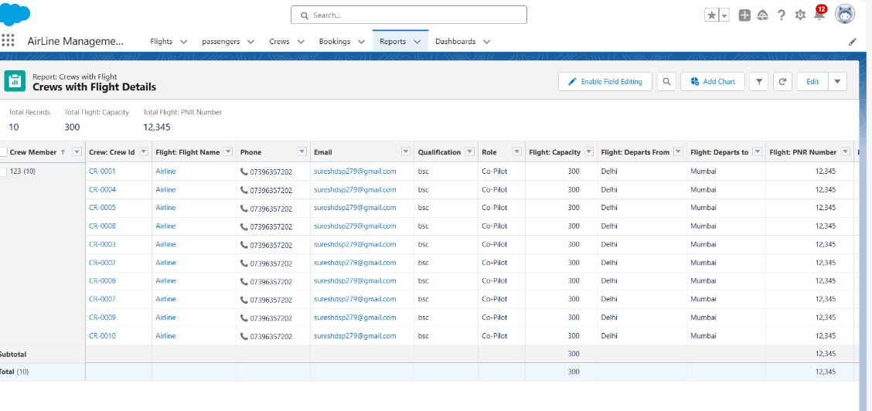

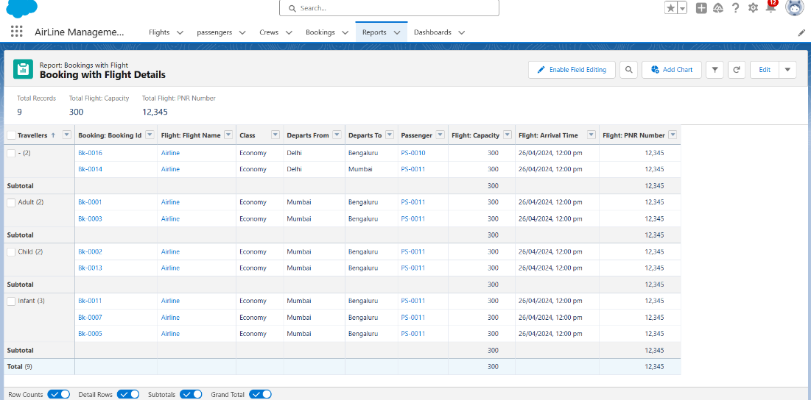

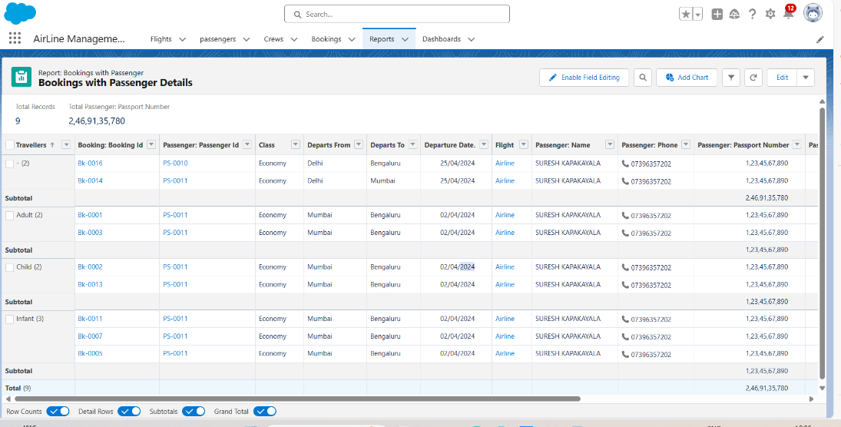

**11) Creating Dashboards**

**TSK-180460**

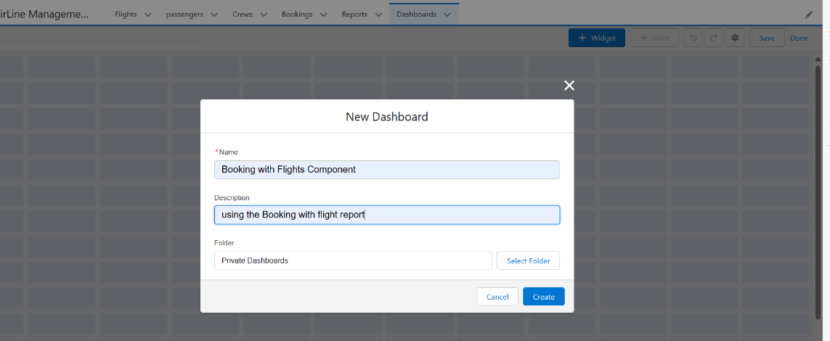

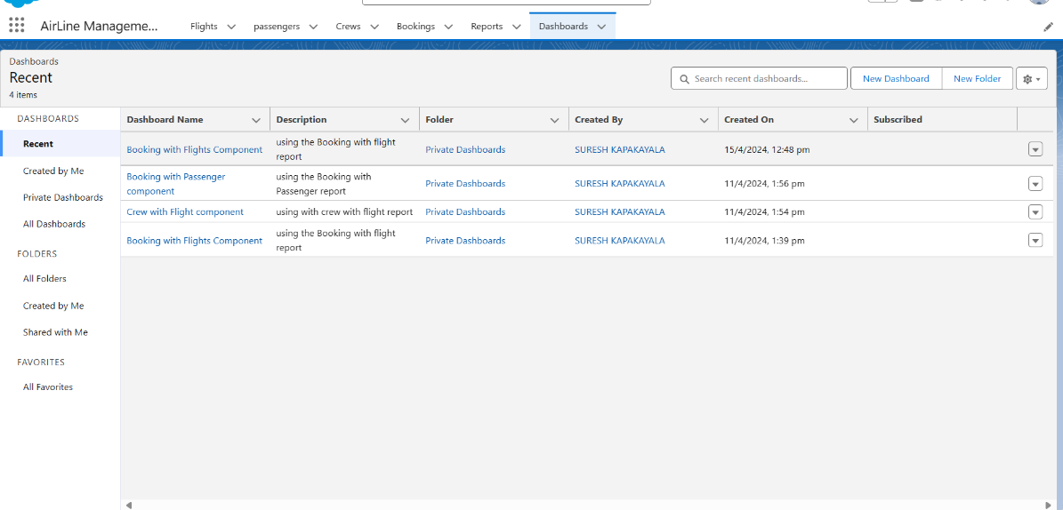

**Created Dashboards**

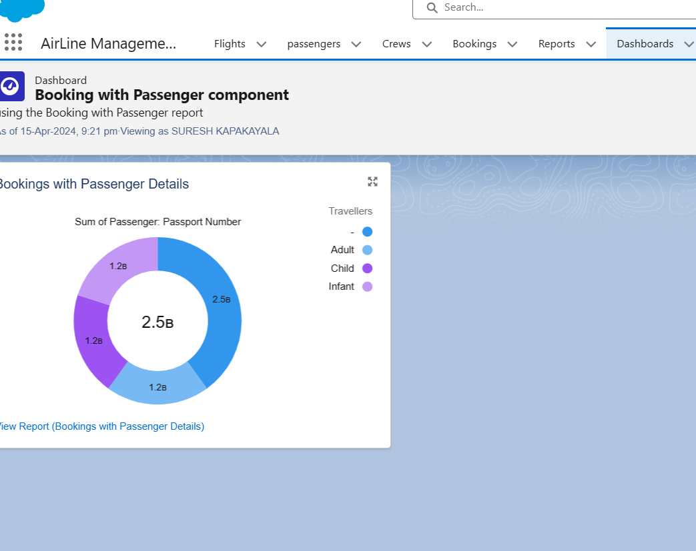

**TSK-180461**

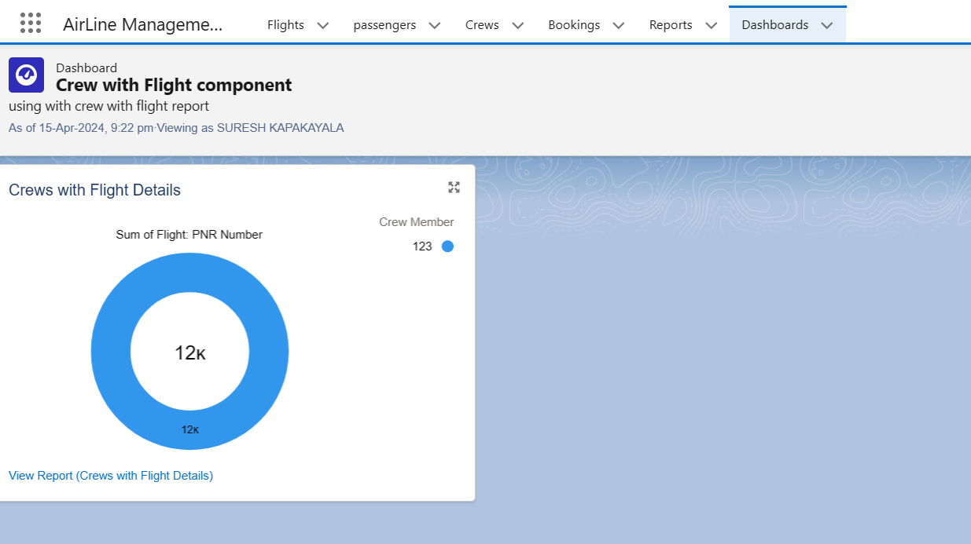

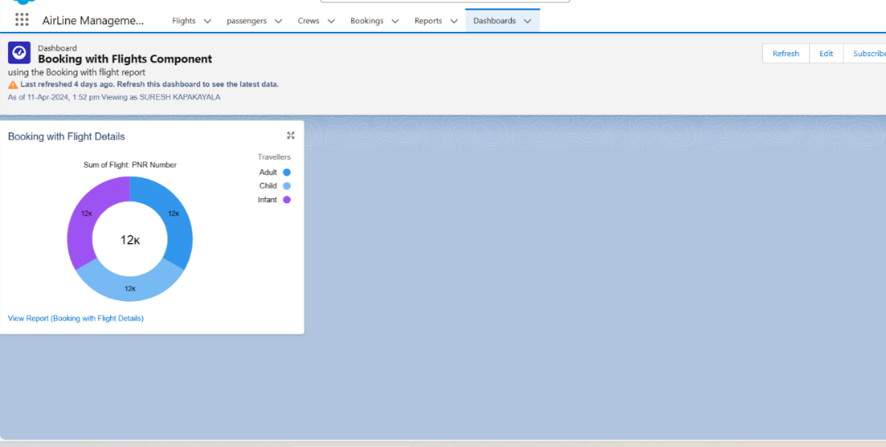

**12) Apex**

**TSK-180462**

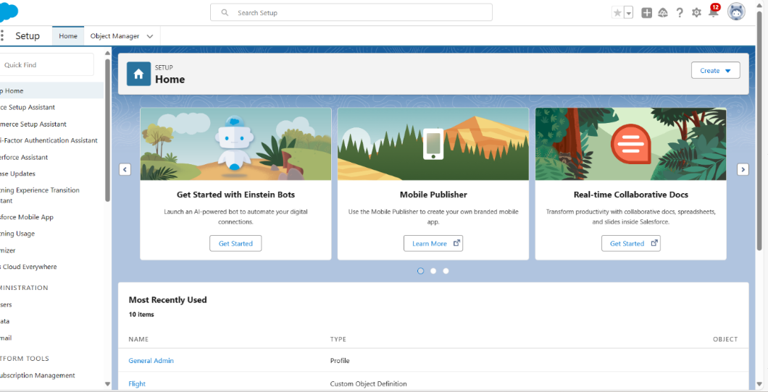

**Creating an apex class**

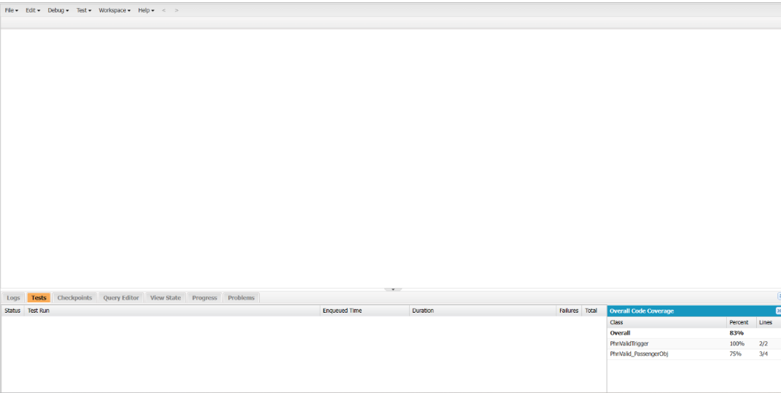

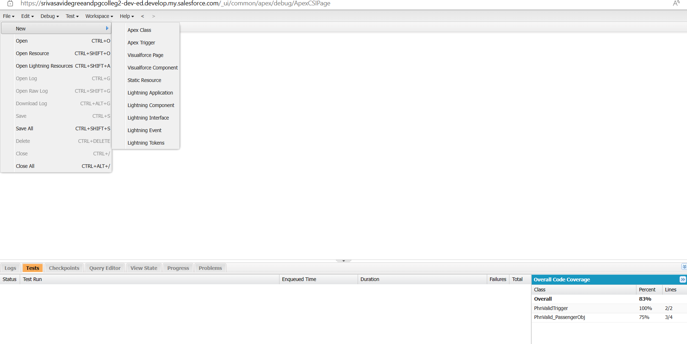



**Created an apex class**

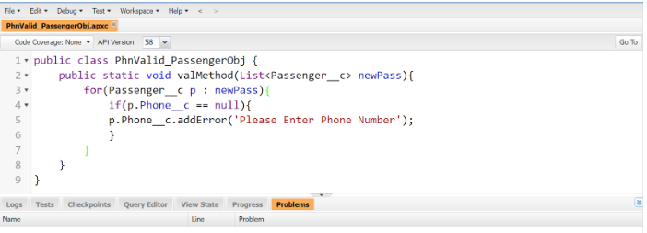

**Creating an apex trigger**

**TSK-180463**



**Created an apex trigger**

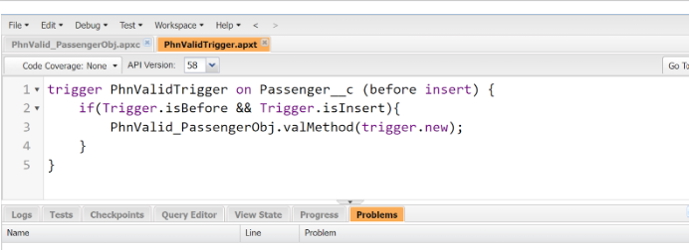

**Created an apex test class**

**TSK-180464**

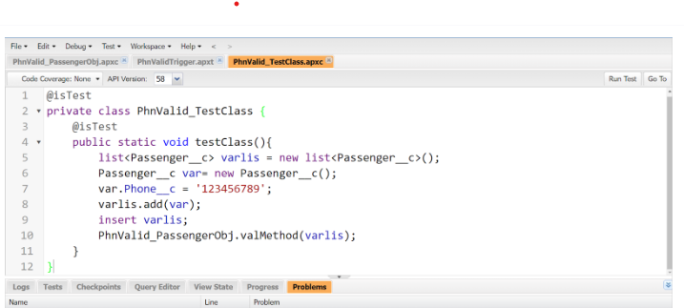

### **13) Creating A Screen Element On Booking Object**

**TSK-180465**

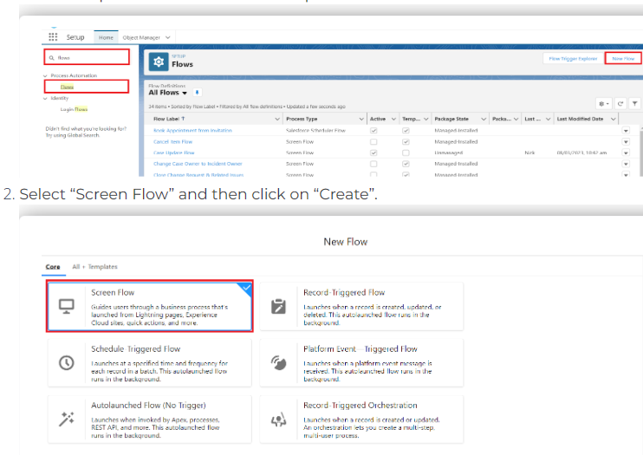

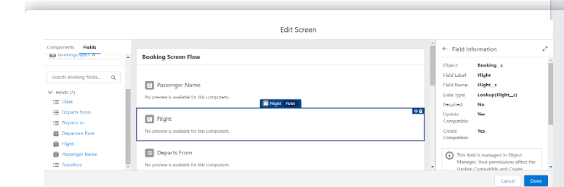

### **Created A Screen Element On Booking Object**

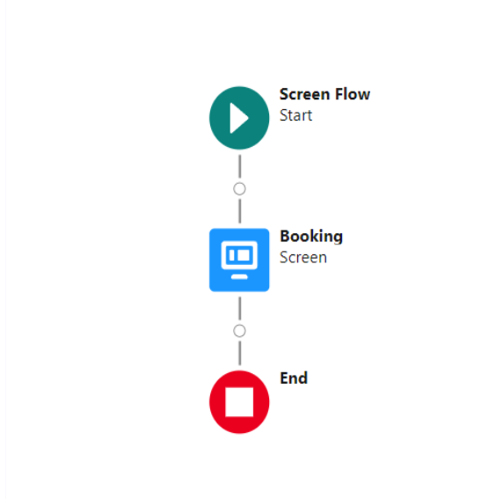

### **Creating A Create Element On Booking Object**

**TSK-180466**

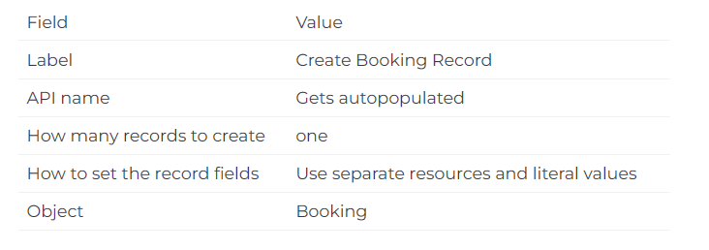

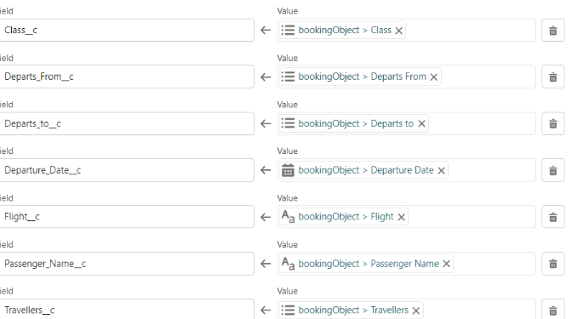

### **Created A Create Element On Booking Object**

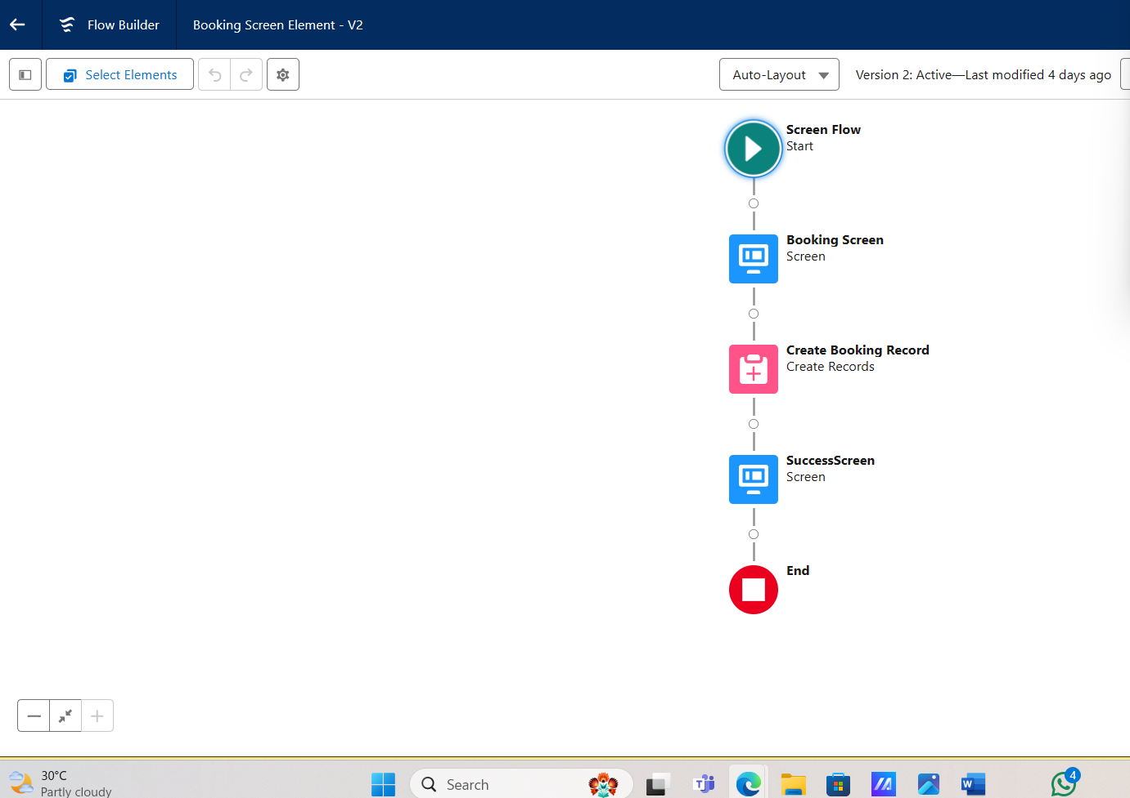

### **Creating A Success Screen Element**

**TSK180467**

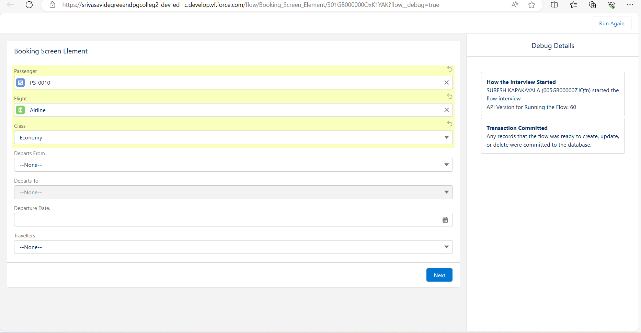

### **Created A Success Screen Element**

